 | 12.1.22 Editors - Geometry Nodes Editor - Header - Add Menu - Utilities
Table of content
Detailed table of content 1
Add menu - Utilities 7
Accumulate Field 7
Align Euler to Vector 8
Boolean Math 8
Clamp 9
Compare 10
Evaluate at Index 11
Float Curve 12
Float to Integer 14
Evaluate on Domain 14
Map Range 15
Math 16
Mix 20
Random Value 23
Rotate Euler 23
Switch 24

Detailed table of content
Detailed table of content
Detailed table of content 1
Add menu - Utilities 7
Accumulate Field 7
Inputs 7
Value 7
Group Index 7
Properties 7
Data Type 7
Outputs 7
Leading and Trailing 7
Total 7
Align Euler to Vector 8
Inputs 8
Rotation 8
Factor 8
Vector 8
Properties 8
Align Axis 8
Pivot 8
Output 8
Rotation 8
Boolean Math 8
Inputs 8
Boolean 8
Properties 9
Operation 9
And 9
Or 9
Not 9
Not And (NAND) 9
Nor (NOR) 9
Equal (XNOR) 9
Not Equal (XOR) 9
Imply (IMPLY) 9
Subtract (NIMPLY) 9
Output 9
Clamp 9
Inputs 9
Value 9
Min 10
Max 10
Properties 10
Clamp Type 10
Min Max 10
Range 10
Outputs 10
Result 10
Compare 10
Inputs 10
A, B 10
Properties 10
Input Type 10
Operation 11
A is less than B 11
A is lesser than or equal B 11
A is greater than B 11
A is greater than or equal B 11
A is equal B 11
A is not equal B 11
Output 11
Result 11
Evaluate at Index 11
Inputs 11
Index 11
Value 11
Properties 11
Data Type 11
Domain 12
Output 12
Value 12
Float Curve 12
Inputs 12
Factor 12
Attribute 12
Properties 12
Curve Field 12
Channel buttons 12
Navigation elements 12
Zoom in and out 12
Use Clipping 13
Tools 13
Reset View 13
Extend horizontal 13
Extend extrapolated 13
Reset Curve 13
Curve edit field 13
Selecting Points 13
Adding Points 13
Curve point settings 13
Vector Handle 13
Auto Handle 14
Auto Clamped Handle 14
Output 14
Value 14
Float to Integer 14
Inputs 14
Float 14
Properties 14
Rounding Mode 14
Outputs 14
Integer 14
Evaluate on Domain 14
Inputs 14
Value 14
Properties 15
Data Type 15
Domain 15
Outputs 15
Value 15
Map Range 15
Inputs 15
Value 15
From Min 15
From Max 15
To Min 15
To Max 15
Properties 16
Data Type 16
Interpolation Type 16
Clamp 16
Outputs 16
Value 16
Math 16
Inputs 16
Value 16
Addend 16
Base 16
Exponent 16
Epsilon 16
Distance 16
Min 17
Max 17
Increment 17
Scale 17
Degrees 17
Radians 17
Properties 17
Operation 17
Functions 17
Add 17
Subtract 17
Multiply 17
Divide 17
Multiply Add 17
Power 17
Logarithm 18
Square Root 18
Inverse Square Root 18
Absolute 18
Exponent 18
Comparison 18
Minimum 18
Maximum 18
Less Than 18
Greater Than 18
Sign 18
Compare 18
Smooth Minimum 18
Smooth Maximum 18
Rounding 18
Round 18
Floor 18
Ceil 19
Truncate 19
Fraction 19
Modulo 19
Wrap 19
Snap 19
Ping-pong 19
Trigonometric 19
Sine 19
Cosine 19
Tangent 19
Arcsine 19
Arccosine 19
Arctangent 19
Arctan2 19
Hyperbolic Sine 19
Hyperbolic Cosine 19
Hyperbolic Tangent 20
Conversion 20
To Radians 20
To Degrees 20
Clamp 20
Outputs 20
Value 20
Use Clipping 20
Delete Points 20
Curve window 20
X / Y values 20
Mix 20
Input 21
Float 21
Factor 21
A 21
B 21
Vector 21
Factor mode Uniform 21
Factor 21
A 21
B 21
Factor mode Non Uniform 21
Factor 21
A 21
B 21
Color 21
Factor 21
A 21
B 21
Properties 22
Data Type 22
Float mode 22
Clamp Factor 22
Vector mode 22
Factor mode 22
Clamp Factor 22
Color mode 22
Blending mode 22
Clamp Result 22
Clamp Factor 22
Output 22
Result 22
Random Value 23
Input 23
Min 23
Max 23
ID 23
Seed 23
Properties 23
Data Type 23
Output 23
Value 23
Rotate Euler 23
Inputs 23
Rotation 23
Rotate By 23
Properties 24
Rotate Type 24
Axis Angle 24
Euler 24
Rotate Space 24
Object 24
Point 24
Outputs 24
Rotation 24
Switch 24
Inputs 24
Switch 24
A 24
B 24
Properties 25
Input Type 25
Outputs 25
Output 25

Add menu - Utilities
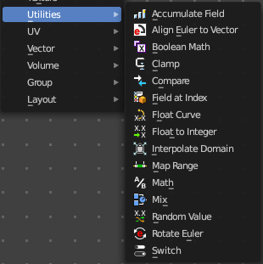
Utility nodes are mainly for mathematical operations.

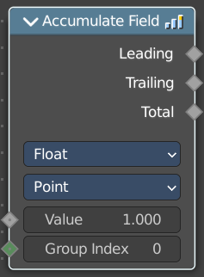
Accumulate Field
Creates a running total of a given Vector, Float, or Int field.

Inputs

Value
The field to be accumulated.

Group Index
The values of this input are used to aggregate the input into separate 'bins', creating multiple accumulations.

Properties

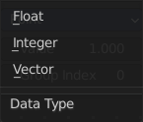
Data Type
What data type to work with.

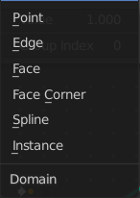
Domain
From which domain to use the data.

Outputs

Leading and Trailing
Returns the running totals starting at either the first value of each accumulations or 0 if there is no data

Total
Returns the total accumulation at all positions of the field.

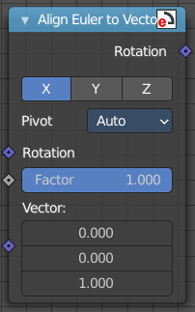
Align Euler to Vector
Aligns a euler value to a vector.

Inputs

Rotation
The input euler rotation vector.

Factor
The factor to align the euler value to the vector.

Vector
The vector to align to.

Properties

Align Axis
To which axis to align the vector.

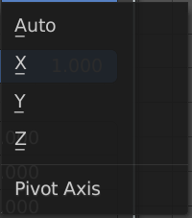
Pivot
The pivot axis.

Output

Rotation
The output rotation euler angle.

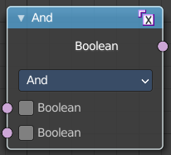
Boolean Math
The Boolean Math node performs a basic logical operation between its inputs.

Inputs

Boolean
Two standard Boolean inputs.

Properties

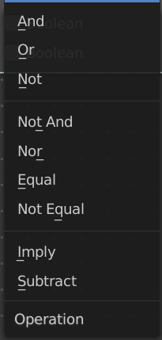
Operation

And
True if both inputs are true.

Or
True if either or both inputs are true.

Not
True if both inputs are false.

Not And (NAND)
True when at least one input is false.

Nor (NOR)
True when both inputs are false.

Equal (XNOR)
True when both inputs are equal.

Not Equal (XOR)
True when both inputs are different.

Imply (IMPLY)
True unless the first input is true and the second is false.

Subtract (NIMPLY)
True when the first input is true and the second is false.

Output
Boolean
Standard Boolean output.

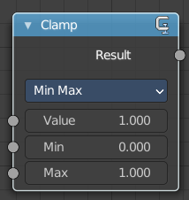
Clamp
Clamps a value between a minimum and a maximum.

Inputs

Value
The input value to be clamped.

Min
The minimum value.

Max
The maximum value.

Properties

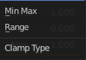
Clamp Type

Min Max
Clamp values using Min and Max values.

Range
Clamp values between Min and Max range.

Outputs

Result
The input value after clamping.

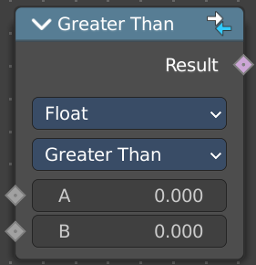
Compare
The Compare node takes two inputs and does a math comparison between them.

Inputs

A, B
Standard float value input.

Properties

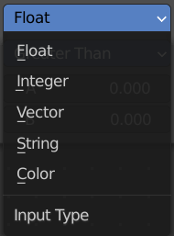
Input Type
What kind of data to compare.

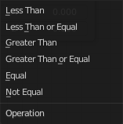
Operation

A is less than B
True if A is smaller than B.

A is lesser than or equal B
True if A is smaller or equal than B.

A is greater than B
True if A is bigger than B.

A is greater than or equal B
True if A is bigger or equal than B.

A is equal B
True if A and B are the same.

A is not equal B
True if A and B are different.

Output

Result
Standard Boolean output.

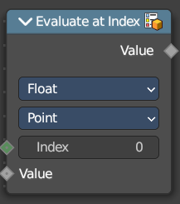
Evaluate at Index
This node allows accessing data of other elements in the context geometry.
It is similar to the Transfer Attribute node in Index mode. The main difference
is that this node does not require a geometry input, because the context
is used.

Inputs

Index
Input Index.

Value
Input Value.

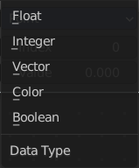
Properties

Data Type
What data type to calculate.

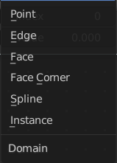
Domain
What geometry to calculate.

Output

Value
The output value.

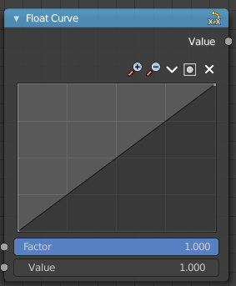
Float Curve
The Float Curve node maps an input float to a curve and outputs a float value. This curve can then be used for profiles for example.

Inputs

Factor
How strong the input influences the output value.

Attribute
The input value.

Properties

Curve Field

Channel buttons
Clicking on one of the channels displays the curve for each.
C (Combined RGB), R (Red), G (Green), B (Blue).

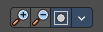
Navigation elements
They are described from left to right.

Zoom in and out
The two buttons with the magnifying glass at it zooms in and out in the curve window.


Use Clipping
Clipping options. Set up clipping for the stroke.

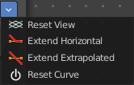
Tools
Tools is a menu where you can find some curve related tools.

Reset View
Resets the curve windows zoom.

Extend horizontal
Extends the curve before the first curve point and behind the last curve point horizontally.

Extend extrapolated
Extends the curve before the first curve point and behind the last curve point extrapolated.

Reset Curve
Resets the curve to the initial shape.

Curve edit field
Create and tweak a Bezier curve that varies the input levels (X axis) to produce an output level (Y axis).

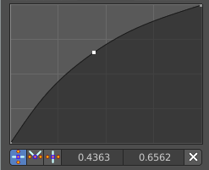
Selecting Points
You can select curve points. This reveals two edit boxes for the x and y coordinate of this point.
Selected points can be moved around. Left click at them, hold the mouse button down and move them to a new location.

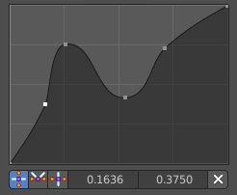
Adding Points
You can add new curve points by simply left clicking at the curve. Move the mouse to position them where you need it.

Curve point settings
When you have a point selected then you will reveal further settings at the bottom.

Vector Handle
Set handle type to Vector.

Auto Handle
Set handle type to Auto.

Auto Clamped Handle
Set handle type to Auto Clamped.

Output

Value
The output value.

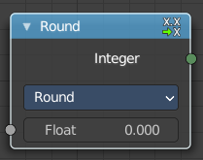
Float to Integer
Converts a floating point value into an integer value.

Inputs

Float
The input float value.

Properties

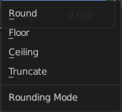
Rounding Mode
How the float value should be converted.

Outputs

Integer
The output integer value.

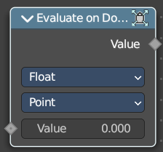
Evaluate on Domain
This node evaluates an existing field on a separate domain in a larger field context - an alternative to the Capture Attribute node. This nodes gets the field type of an existing field from the input socket and interpolates the field type as an array in the output socket.

Inputs

Value
The input value to get the field.

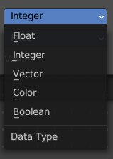
Properties

Data Type
Select the Data Type - which can be float, integer, vector, color and boolean.

Domain
The domain the Field evaluates. This gets and filters the field type. The domain can be point, edge, face, face corner, spline or instance.
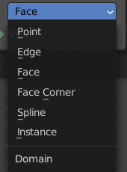

Outputs

Value
The output value.

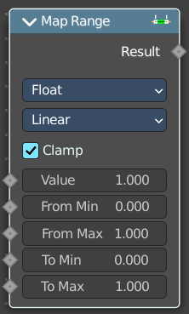
Map Range
This node converts (maps) an input value range into a destination range. By default, values outside the specified input range will be proportionally mapped as well. This node is similar to Map Value node but provides a more intuitive way to specify the desired output range.

Inputs

Value
Standard value input.

From Min
Start of the input value range.

From Max
End of the input value range.

To Min
Startof the destination range.

To Max
End of the destination range.

Properties

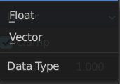
Data Type
The data type to calculate.

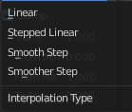
Interpolation Type
how to interpolate the values between min and max.

Clamp
Clamps values to Min/Max of the destination range.

Outputs

Value
Standard value output.

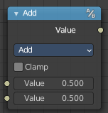
Math
The Math Node performs math operations.

Inputs
The inputs of the node are dynamic. Some inputs are only available with certain operations. For example, the Addend input is only available in the Multiply Add operator.

Value
Input Value. Trigonometric functions read this value as radians.

Addend
Input Addend.

Base
Input Base.

Exponent
Input Exponent.

Epsilon
Input Epsilon.

Distance
Input Distance.

Min
Input Minimum.

Max
Input Maximum.

Increment
Input Increment.

Scale
Input Scale.

Degrees
Input Degrees.

Radians
Input Radians.

Properties

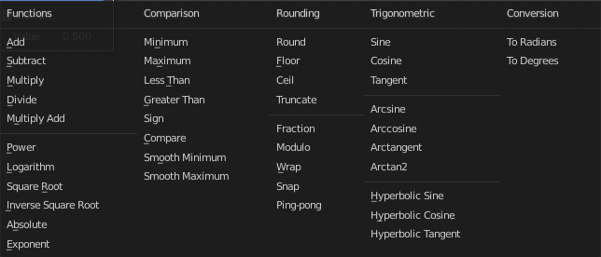
Operation
The mathematical operator to be applied to the input values:

Functions

Add
The sum of the two values.

Subtract
The difference between the two values.

Multiply
The product of the two values.

Divide
The division of the first value by the second value.

Multiply Add
The sum of the product of the two values with Addend.

Power
The Base raised to the power of Exponent.

Logarithm
The log of the value with a Base as its base.

Square Root
The square root of the value.

Inverse Square Root
One divided by the square root of the value.

Absolute
The input value is read with without regard to its sign. This turns negative values into positive values.

Exponent
Raises Euler’s number to the power of the value.

Comparison

Minimum
Outputs the smallest of the input values.

Maximum
Outputs the largest of two input values.

Less Than
Outputs 1.0 if the first value is smaller than the second value. Otherwise the output is 0.0.

Greater Than
Outputs 1.0 if the first value is larger than the second value. Otherwise the output is 0.0.

Sign
Extracts the sign of the input value. All positive numbers will output 1.0. All negative numbers will output -1.0. And 0.0 will output 0.0.

Compare
Outputs 1.0 if the difference between the two input values is less than or equal to Epsilon.

Smooth Minimum
Smooth Minimum.

Smooth Maximum
Smooth Maximum.

Rounding

Round
Round the input value to the nearest integer.

Floor
Rounds the input value down to the nearest integer.

Ceil
Rounds the input value up to the nearest integer.

Truncate
Outputs the integer part of the value.

Fraction
Fraction.

Modulo
Outputs the remainder once the first value is divided by the second value.

Wrap
Outputs a value between Min and Max based on the absolute difference between the input value and the nearest integer multiple of Max less than the value.

Snap
Round the input value to down to the nearest integer multiple of Increment.

Ping-pong
The output value is moved between 0.0 and the Scale based on the input value.

Trigonometric

Sine
The Sine of the input value.

Cosine
The Cosine of the input value.

Tangent
The Tangent of the input value.

Arcsine
The Arcsine of the input value.

Arccosine
The Arccosine of the input value.

Arctangent
The Arctangent of the input value.

Arctan2
Outputs the Inverse Tangent of the first value divided by the second value measured in radians.

Hyperbolic Sine
The Hyperbolic Sine of the input value.

Hyperbolic Cosine
The Hyperbolic Cosine of the input value.

Hyperbolic Tangent
The Hyperbolic Tangent of the input value.

Conversion

To Radians
Converts the input from degrees to radians.

To Degrees
Converts the input from radians to degrees.

Clamp
Limits the output to the range (0.0 to 1.0). See Clamp.

Outputs

Value
Numerical value output.


Use Clipping
Clipping options. Set up clipping for the stroke.

Delete Points
Deletes selected curve point.

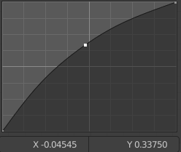
Curve window
Tweak and adjust the falloff curve by clicking at a curve point and dragging it around.
Double click adds a new point.
Holding down ctrl activates temporary snapping.
Holding down shift enables slower movement, which allows more accurate setting.

X / Y values
The x and y value of the currently selected point.

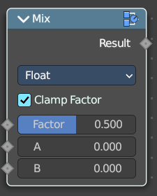
Mix
Allows to mix values and vectors in various ways. The node has three different modes. Float, Vector and Color

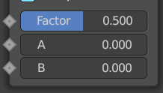
Input

Float

Factor
The mix factor.

A
Float value A input.

B
Float value B input.

Vector

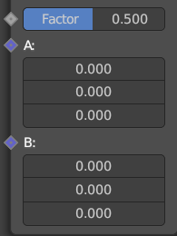
Factor mode Uniform

Factor
The mix factor.

A
Vector A input.

B
Vector B input.

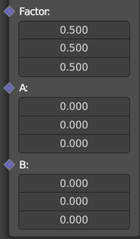
Factor mode Non Uniform

Factor
The vector mix factor.

A
Vector A input.

B
Vector B input.

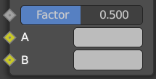
Color

Factor
The mix factor.

A
Color A input.

B
Color B input.

Properties

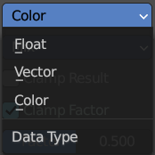
Data Type
Which mode to use.

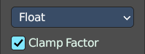
Float mode

Clamp Factor
Clamp the factor to 0-1 range.

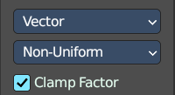
Vector mode

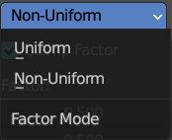
Factor mode
Uniform or non uniform factor.

Clamp Factor
Clamp the factor to 0-1 range.

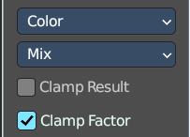
Color mode

Blending mode
What blending mode to use for the color.

Clamp Result
Clamp the result to 0-1 range.

Clamp Factor
Clamp the input factor to 0-1 range.

Output

Result
The output value or vector.

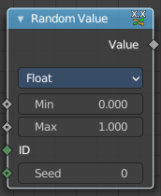
Random Value
Generates a random value.

Input

Min
The minimum value of the range. This input is only available for Float, Integer, and Vector types.

Max
The maximum value of the range. This input is only available for Float, Integer, and Vector types.

ID
An ID to drive the random number generator seed. By default, this input uses the same value as if the ID Node, which is the id attribute of the context geometry if it exists, and otherwise the index.

Seed
The random seed for the random number generation.

Properties

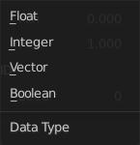
Data Type
What kind of random value to create. The items should be self explaining.

Output

Value
The output value.

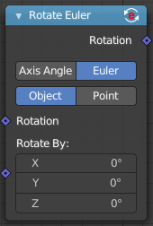
Rotate Euler
Rotates an euler rotation.

Inputs

Rotation
Use the rotation of an existing geometry.

Rotate By
The input rotation.

Properties

Rotate Type

Axis Angle
Rotate around an axis by an angle.

Euler
Rotate around the x, y and z axis.

Rotate Space

Object
Rotate points in the local space of the object.

Point
Rotate every point in its local space.

Outputs

Rotation
The euler angle output.

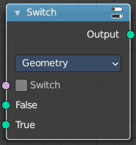
Switch
Switch between two inputs values based on a boolean.

Inputs

Switch
The boolean switch.

A
The input value A. Used when the switch is off.

B
The input value B. Used when the switch is on.

Properties

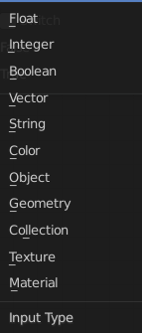
Input Type
What input type the values are, which defines what type to output then.

Outputs

Output
Numerical value output.

